Hydrocarbon Liquid Leak Detection System
SPECIFICATION
---
Building Service

- General
Furnish a complete hydrocarbon leak detection system, including electronic alarm module, hydrocarbon sense cable, and accessories. The system shall detect and locate liquid hydrocarbon leaks along full length of sense cables to give continuous protection to the critical areas of the Project Facilities [Installation to be specified, i.e. Day Tanks, Gensets, Storage Tanks] from the risk of [hydrocarbon] [non-conductive] liquid leaks.
The system manufacturer shall have at least ten years of experience with leak detection and location technology, including both sense cable and the associated alarm electronics.

- Overall System
The liquid leak detection system shall be able to locate multiple [hydrocarbon] [non-conductive] liquid leaks simultaneously as well as cable break faults (one per sensor).
This system shall be able to monitor both [hydrocarbon] [non-conductive] liquid leak sense cables and [water] [acid solution] [basic solution] leak sense cables on a single digital unit.
The system shall be compliant to hazardous atmosphere locations in ATEX zones 0, 1 and 2, sense cable shall be intrinsically safe for gases of groups IIA and IIB, tested to Standard IEC 60079, IECEx approved by a recognized worldwide third-party certification body.
- Type
The detection system shall be composed of the following elements:
- FG-NET digital monitoring unit, manufactured by TTK, or equivalent,
- FG-BBOX satellite device (if required), manufactured by TTK, or equivalent,
- FG-OD addressable sense cables (sense cables), manufactured by TTK, or equivalent,
- Jumper cables and all required ancillary equipment.

- Sense Cable

  - Performances
The hydrocarbon sense cable shall detect the presence of diesel, gasoline, jet fuel and other liquid hydrocarbons.
The hydrocarbon sense cable shall ignore water and be insensitive to small pollutions, dirt and external loads.
The cable shall be reusable after leak detection.
  - Construction and Certification Requirements
Each sense cable shall:
- have an embedded microchip circuit allowing the transmission of an addressable signal to the digital monitoring unit,
- be connected via male and female connectors,
- be made of light and flexible material in an easily identifiable color,
- undergo to a mostly reversible [hydrocarbon] [non-conductive] liquid absorption, allowing for absorbed liquid to be cleaned with appropriate solvent,
- be certified for safe use in ATEX Zone 0, protection mode “IA”, Group IIB, Temperature Class T4.

- System Capacity
The monitoring unit shall be capable of monitoring up to 120 sense cables directly connected (that’s 1440 meters), and up to 500 sense cables (that’s 6000 meters) connected via satellite units (FG-BBOX or equivalent).
A Zener Barrier device (if required) shall be installed to allow use of sense cables in Hazardous Locations (ATEX Zone 0, e.g. for Group IIB).
The monitoring unit shall be able to show all the cables connected and group them by zone.
The monitoring unit shall be able to monitor three independent circuits of sense cables.

- Digital Monitoring Unit
The digital monitoring unit shall receive data processed and transmitted by each sensor as well as raising the alarm. It shall be supplied from the same supplier as the sense cables.
Contact with liquid shall result in an audible and visual alarm, activation of an output relay, and shall notify the user in distance by remote monitoring.
  - Multiple leaks
The electronic alarm module shall continue to monitor the sense cable after detection of liquid. It shall re-alarm if the liquid spreads or migrates beyond the initial section in leak alarm, or if a second leak is detected on another section, at any location along the sensing circuit. The system shall be able to detect as many leaks as the number of sections are installed.
  - Cable break fault
The complete system shall be continuously monitored for electrical continuity. The loss of continuity in any of the wires shall result in an audible alarm, illumination of an alarm LED, and actuation of an output relay. The system shall be capable of identifying the section of smart sense cable where the continuity is lost.
  - Interface
There shall be 8 configurable dry contacts (relays) available in the system to enable remote monitoring and control. Any interruption in power shall be indicated by a specific dry contact.
RS-232, RS-422/485 serial ports with Modbus/Jbus communication protocol shall be available on the digital monitoring unit.
An Ethernet port shall be available on the monitoring unit.
The digital monitoring unit shall be the model FG-NET manufactured by TTK S.A.S., or equivalent.

- Jumper cable connection and ancillary equipment
Jumper cable shall be available to interconnect sense cable sections or to facilitate remote mounting of the electronic alarm module.

- Installation
The sense cables can be installed above ground or underground (buried).
For aboveground application, such as day tank, storage tank, generator, the sense cables shall be installed in perimeter of the equipment or in tray. The sense cables shall be installed along the pipeline for the tank. See below example figure 1.
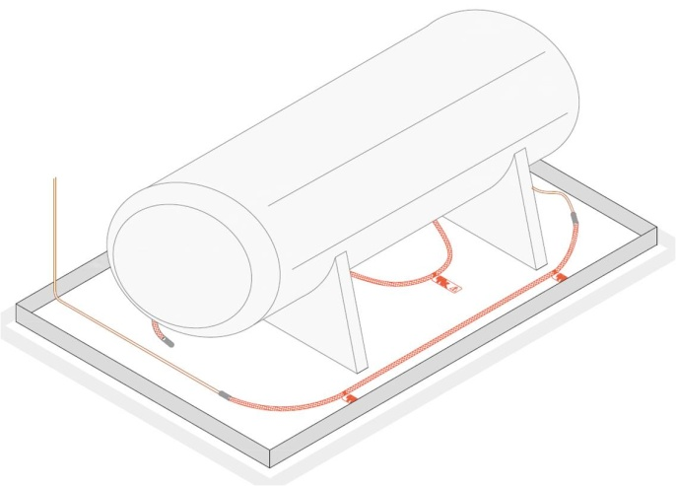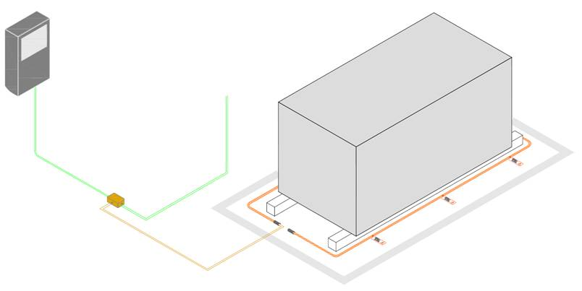
Figure 1: Day tank / Storage Tank / Generator oil leak sense cable installation examples
For underground installations requiring direct burial, such as storage tank, sense cables will have to be run through dedicated plastic slotted pipes (figure 2) to allow cable maintenance (cleaning after leak detection or replacement in case of damage).
Figure 2: sense cable inside a plastic slotted PVC pipe and filtering fabric sleeve
All leak detection system components shall be installed in strict accordance with the manufacturer's installation instructions and the distributor’s submittal drawings.
The installation shall not take place until all construction work to the area of installation is completed, all debris and construction by products have been taken away and the area cleaned.

The appointed contractor shall ensure that the system is installed by a TTK trained partner who shall create as built drawings. A site map prepared from the leak detection supplier’s "as built" drawings shall be furnished by the equipment supplier after completion of the installation. The map shall indicate the location of the cable, connectors, and landmarks such as equipment, piping access ports, change of cable direction, and cable distance readings per manufacturer's instructions. Copies of the map drawing shall be provided to the engineer, the owner, and a laminated display version shall be mounted near the alarm module.

- Manufacturer
The Digital Oil Leak Detection system shall be manufactured by:
TTK S.A.S.
19 rue du Général Foy Tel: +33.1.56.76.90.10
75008 Paris Fax: +33.1.55.90.62.15
France
Websites: http://www.ttk.fr,
http://www.ttkuk.com,
http://www.ttkasia.com,
http://www.ttkusa.com
http://www.ttkcanada.com

